Want to bring your neighbors together to tackle a common concern, build community, and improve your neighborhood? Here is a step-by-step guide on designing a community project.

Step 1: Set a Goal
Identify an existing community need or goal. What do you and your neighbors want to see in your neighborhood? Why is this a priority? Ensuring that the project meets a need will help you tap into your community’s wellspring of energy and increase your likelihood of getting the volunteers and support that are key to a successful project. Talking to your neighbors is a great way to gauge interest and brainstorm additional project elements that will take it a step further.

Step 2: Make a Plan
Create a detailed plan on how to achieve your goal. This will help you identify the necessary next steps. Some details to consider are:
- Location
- Supplies needed (What needs to be purchased vs. what can be rented or borrowed?)
- Best time of year to conduct the project
- Number of volunteers needed
- Project duration (How long will this take to complete?)
- Permits and permission (Will this take place on public or private land and how will you acquire necessary permissions?)
- Project Maintenance (will you and your neighbors need to host more work parties?)
- Effectiveness (Is your solution sustainable or will it only be a temporary fix?)
- Best practices (Research similar projects that have been conducted elsewhere. What steps did they take to be successful? What barriers were presented and how did they overcome them?)

Step 3: Identify Your Metrics
Identifying your metrics is a great way to reaffirm your project goals and how you plan to meet them. Metrics are different project elements that can be measured; this could include the number of volunteers, bags of trash picked up, trees planted, etc. Preparing a chart that you can fill out on the project day will help ensure that you stay organized and goal oriented.

Step 4: Create a Project Timeline
Creating a timeline helps you better understand how much work needs to be conducted and how many volunteers are required. Oftentimes, community members will underestimate the amount of time and work needed to complete a project.

While optimism is important, it is necessary to understand the scope of the work to ensure that the project can be completed in a timely manner without anyone feeling overburdened or overworked. Making sure you understand the time and resources you and your fellow volunteers can dedicate to this project is also important when you are creating a realistic project timeline.

Break down your project into small sections and identify how many days you expect each portion to take. Write down dates if possible. Include the time needed to gather resources and make purchases, and always include several extra days in case there is a setback.

Step 5: Create a Budget
After you’ve outlined the supplies you’ll need, identify how you will gather these supplies and create a budget. Are there any tools you can rent or borrow from neighbors? What supplies can you have donated by local businesses? Are you and your neighbors able to pool resources to fund this project, or will you need to seek outside funding to accomplish your goals?

Items to consider when forming a budget:
- Material costs
- Taxes
- Permitting costs
- Contingency funds
- Fiscal sponsor fee (if applicable)
- Insurance fee (if applicable)

Step 6: Locate Resources
Oftentimes, a project is outside the scope of what community members can fund themselves. Fortunately, there are a wide variety of resources available for community projects. Local businesses, nonprofits, and City programs can all provide support.

View City resources at http://www.seattle.gov/services-and-information/grants-and-funding.

Use the Neighborhood Snapshots (http://www.seattle.gov/neighborhoods/resourcehub/neighborhood-snapshots ) to identify organizations with similar goals that may be able to support your project. This support can go beyond funding; donations can include food, volunteers, meeting space, and more.

Step 7: Recruit Volunteers
Though you may already be working with a group of committed neighbors on this project, reaching out to the broader community will strengthen neighborhood ties, decrease the workload on your existing team of volunteers, and give your project a greater chance of long-term success by creating a broader support network.

Organizations to reach out to:

- Nonprofits
- Schools
- Local businesses
- Community Centers
- Sports teams
- Church groups
- Community groups
- Community councils

Outreach Strategies:

- Social media
- Flyers
- Advertise at community events
- Post on community blogs and calendars

Step 8: Delegate
Once you’ve established a group of volunteers, identify what roles each can take on. Consider if anyone has any skills that can be used, and how much time and energy individuals have to dedicate to the project. Clearly identifying roles and responsibilities will help keep the project on its timeline. If possible, give volunteers dates by which to have certain tasks accomplished. Check in with your volunteers every week or two to keep communication active and open.

Step 9: Conduct the Project
Congratulations! You’ve reached the last stage of your project. By this time, you should have your volunteers organized, your supplies gathered, and your timeline deadlines met. Have a check-in sheet for your volunteers and your metrics chart available. Be sure to take before and after photos!

Other Questions to Consider

Flexibility
How flexible is this project? Which elements can be changed or expanded upon and which can’t? Though having a firm idea of your project goals and timeline is important, a certain degree of flexibility is also needed to ensure the project can overcome any speedbumps along the way. It is also helpful to identify which project elements cannot be changed and which need to be prioritized.

Sustainability
How sustainable is this project? Will neighbors continue to help with maintenance? Does it provide an ongoing service to the community? Is it located somewhere in the neighborhood where it will be commonly used? These questions are important to consider; it is better to give your time and energy to a project that will gain momentum and sustain over time rather than one that ends once the project day is complete.

Materials
Will the materials withstand multiple years of use? Are the plants chosen native to the area and expected to thrive? What kind of weeds, weather, and wear-and-tear can you expect?

Though it seems simple, choosing the wrong materials can derail any well-planned project. Be sure and research what is appropriate for your purposes, and don’t be afraid to seek outside funding if materials cost more than anticipated. It is better to have a project outcome with longevity that will serve your community for years to come.

Examples of Successful Community Projects

Belltown P-Patch Mural
Community members in Belltown came together to paint a mural on a blank concrete wall next to their local P-Patch that attracted graffiti and litter. They chose this project because of its central location and strong community support for the idea. A corps of volunteers was established to maintain the artwork, and it has not only remained in good condition but was expanded to the staircase adjacent to it.

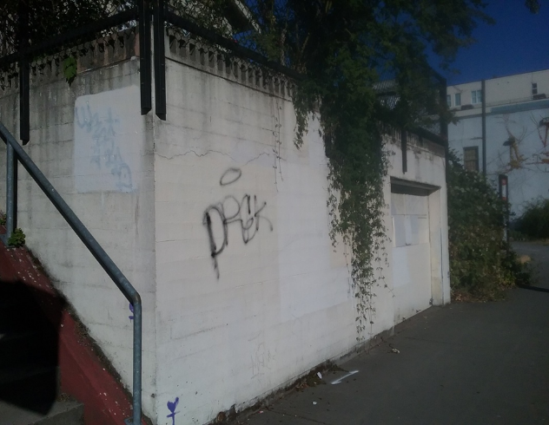
This project brought a stronger sense of community and public ownership to an existing neighborhood hub. It has sustained for years after its initial completion to serve and strengthen the community of Belltown.

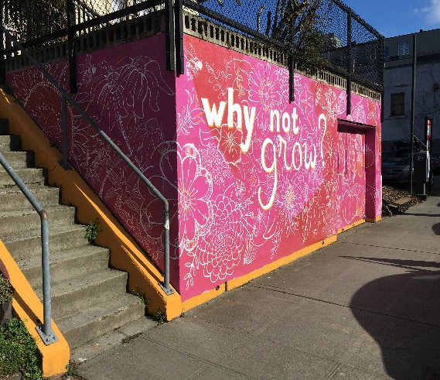

SeaMar Garden Beds
Community members in South Park partnered with SeaMar Community Health Center and Marra Farm to install 4 ADA-compliant raised garden beds for edible plants on SeaMar’s property. The purpose of this project was to provide a way for neighbors and clients to access community gardening and healthy food at little to no cost. Since their installation in 2016, these garden beds have been in active use and 3 more large garden beds and 8 mini planters have been added. This project was successful because it not only served an important purpose within the community, but also tapped into the enthusiasm and resourcefulness of neighbors and local businesses in South Park.
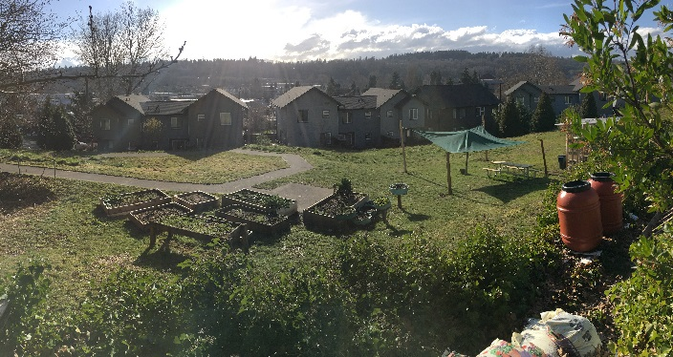

Pinehurst Pocket Park
Neighbors in Pinehurst came together to weed and replant native plants in their local pocket park to increase community use of this green space. Tall shrubs were planted in front of the perimeter fence to discourage graffiti, and 6 types of native ferns and berries were introduced to the park. Over 20 volunteers gathered on a rainy Saturday to conduct this work party, and since that time a corps of volunteers has been established to help maintain the pocket park and reaffirm the community’s stewardship of this space.

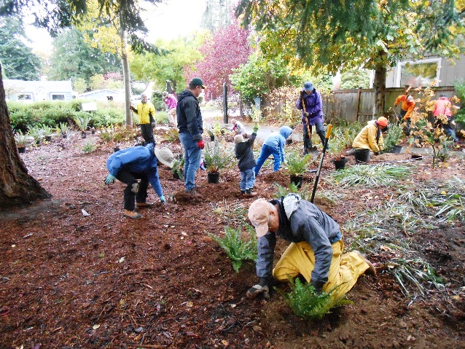
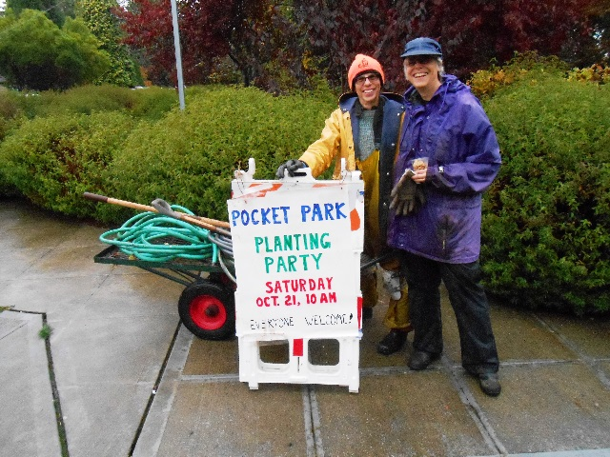

This document created in partnership with:
