
How to Join a Webex Hearing – Smartphone or Tablet
If joining from a smart phone or tablet, you will need to download the Cisco WebEx Meetings application from your app store (iOS or Android) to join with video. You can join by phone only without downloading the app.
- To join with video: First, search for WebEx in your phone’s app store and download the Cisco WebEx Meetings app.
- Open the WebEx app and accept the Terms of Service/Privacy Statement.

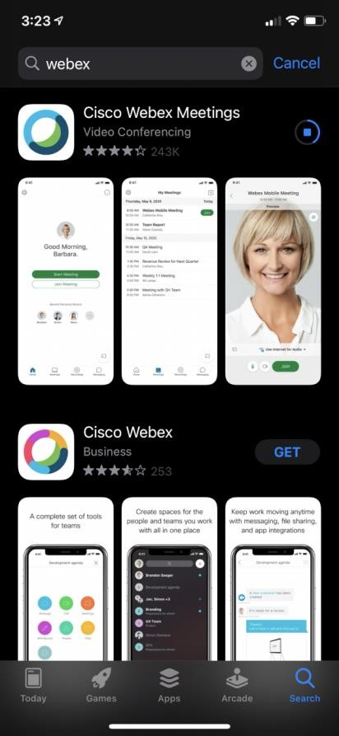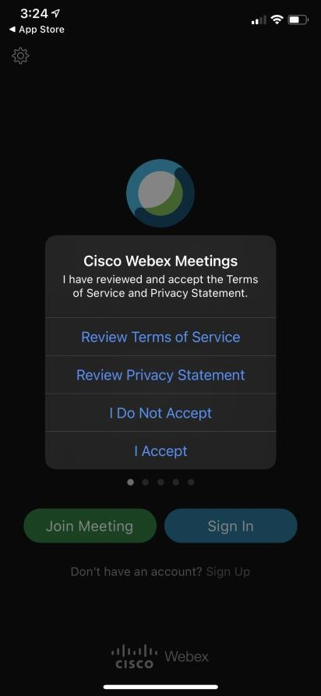

- After you have the app installed, open the Seattle Municipal Court website and click on the courtroom link for your hearing. It will prompt you to open in WebEx—click “Open.” 4. Enter your first and last name and your email, and click “OK.”
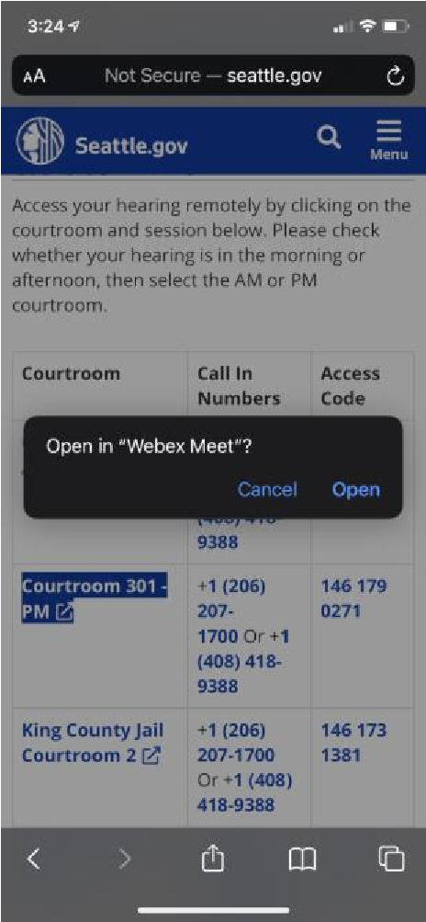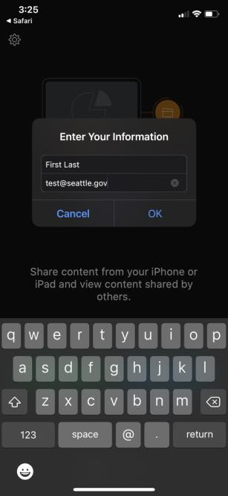

- If prompted, give WebEx access to your microphone and camera by clicking “OK.”
- You can turn your microphone and camera on and off with the icons at the bottom of the screen. When the icons are red and crossed out, it means you are muted and your camera is turned off. Please mute your microphone unless you are speaking and turn your camera on during your hearing.
- When you are ready, click the green “Join” button.
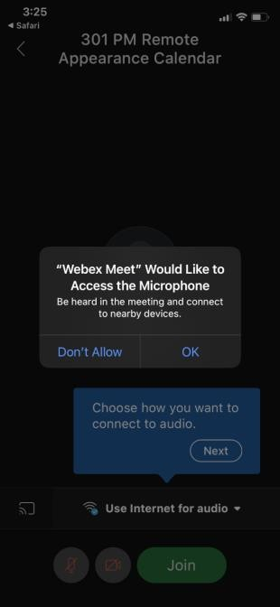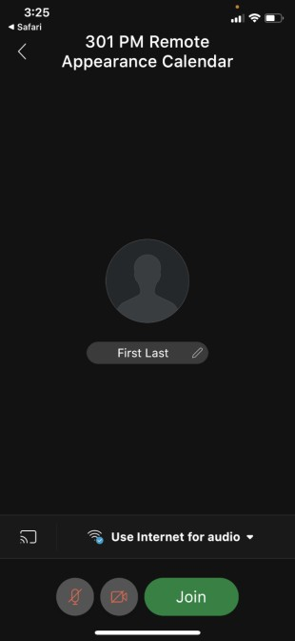

Page 2 December 2020

To join by phone only, without video:
- Open the Seattle Municipal Court website and click on the courtroom link for your hearing. When you click the link, it will prompt you to join by phone only or join by the app.
- Click the top green Call button, then click Call again if your phone prompts you.
- The phone will enter the Access Code number for you, and you will join the meeting. Press *6 on your phone to mute and unmute yourself.
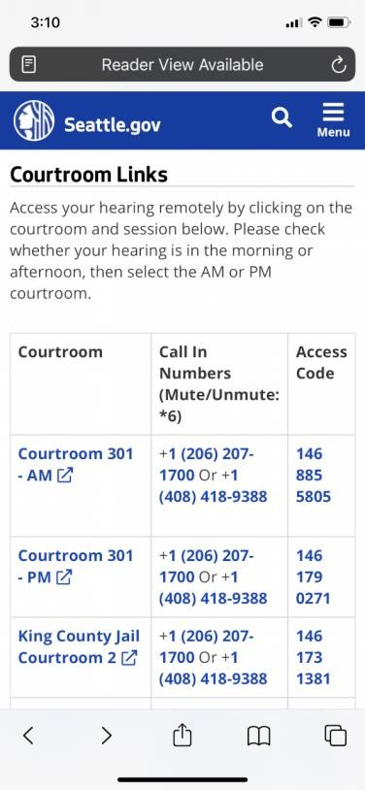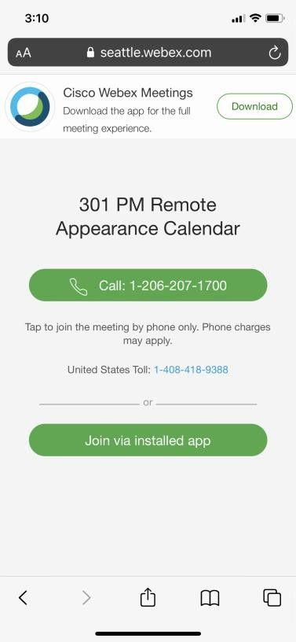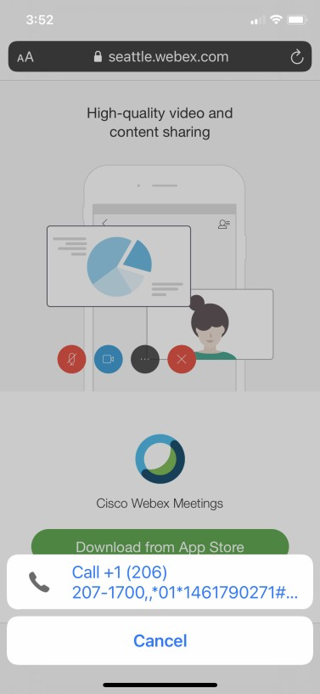

Page 3 December 2020

