
Sida loo Galo Dhegeysi Khadka Webex – Foon-casri ah ama Tablet
Haddii laga soo gelayo foon-casri ah ama tablet, waxaa u baahan doontaa inaad ka soo degsato dukaanka barnaamijta foonkaaga arjiga Cisco WebEx Meetings (iOS ama Android) si aad ugu gashid fiidiyow. Foon keliya waa ku soo geli kartaa adigoon arjiga soo degsan.
- Si loogu galo fiidiyow: Kow, ka raadi WebEx dukaanka barnaamijta foonkaaga oo soo degso arjiga Cisco WebEx Meetings.
- Fur arjiga WebEx oo aqbal Qodobbada Adeegga/Bayaanka Xog-dhawrista.

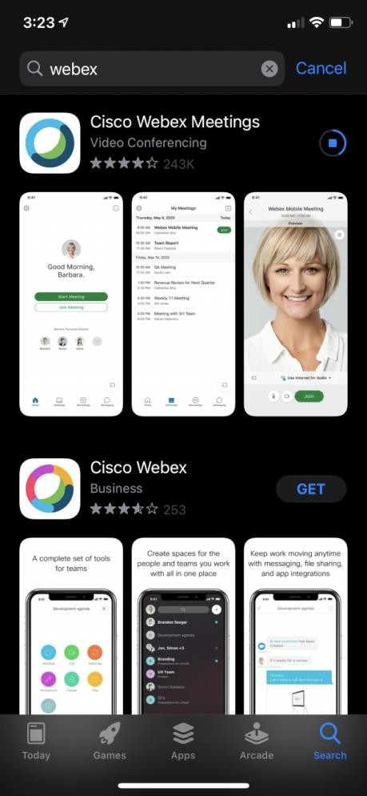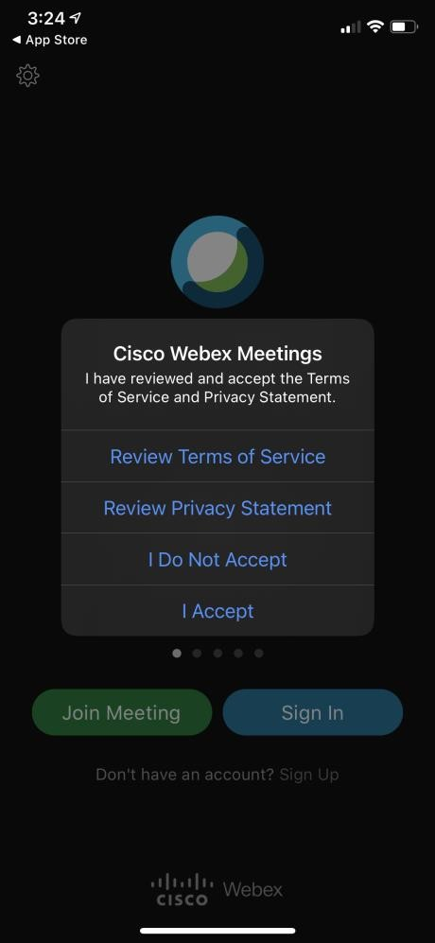

- Kadib markaa ku shubatid arjiga, fur bogga Maxkamadda Magaalada Seattle oo guji iskuxiraha qolka maxkamadda dhegeysigaaga. Wuxuu kaaga furi doonaa WebEx—guji “Open.”
- Geli magacaaga koobaad iyo magacaaga dambe iyo iimeelkaaga, kadib guji “OK.”
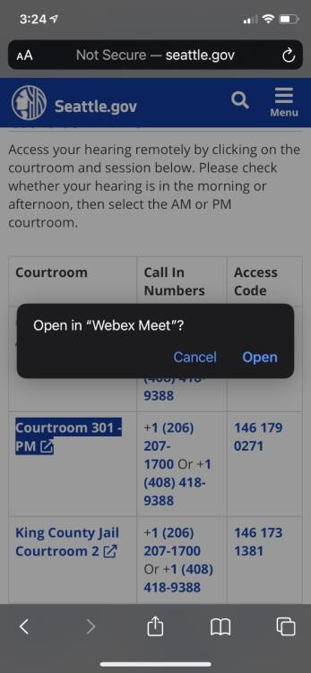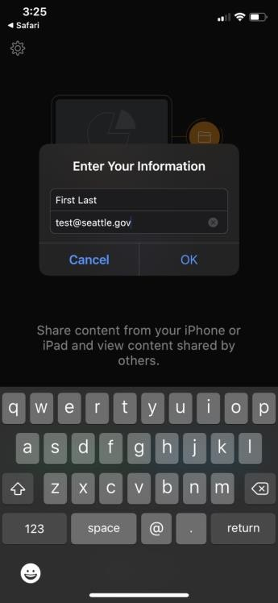

- Hadii lagu weydiiyo, sii oggolaansho WebEx xagga makrafoonkaaga iyo kaamirada ayadoo la gujinayo “OK.”
- Waxaa ku daari ama ku damin kartaa makrafoonkaaga iyo kaamirada calaamadaha shaashadda hoosteeda. Markey calaamaduhu guduudanyihiin oo xariijin dhexmarsantahay, macnaheedu waa codkaagu waa xiranyahay kaamiradaaduna wey dansantahay. Fadlan makrafoonkaaga codka ka xir illaa aad hadleysid mooyaane kaamiradaadana daar inta dhegeysigaaga lagu jiro.
- Markaa diyaartahay, guji batoonka “Join meeting” ee cagaaran.
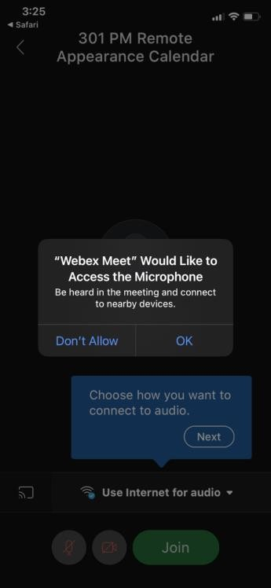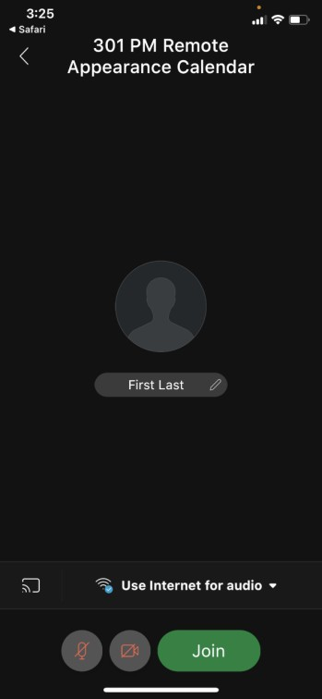

Si loogu galo foon keliya, la’aanta fiidiyow:
  - Fur bogga Maxkamadda Magaalada Seattle oo guji isku-xiraha qolka maxkamadda dhegeysigaaga. Markaa gujisid isku-xiraha, wuxuu ku weydiin doonaa inaad foon keliya ku gashid ama arjiga ku gashid.
  - Guji batoonka Wicitaanka (Call) cagaaran ee kore, oo markale guji Wicitaan haddii foonkaagu ku weydiiyo.
  - Foonka ayaa lambarka Furaha Gelidda kuu gelin doona, waxaana geli doontaa kulanka. Riix *6 si aad codka foonkaaga uga xirtid ama uga furtid.

