
Sida loo Galo Dhegeysi Khadka Webex – Laptop ama Kumbuyuutar
- Haddii laga soo gelayo laptop ama kumbuyuutar, guji isku-xiraha kulanka dhegeysigaaga.
- Guji “Join from your browser.”(Kasoo gal khadkaaga)

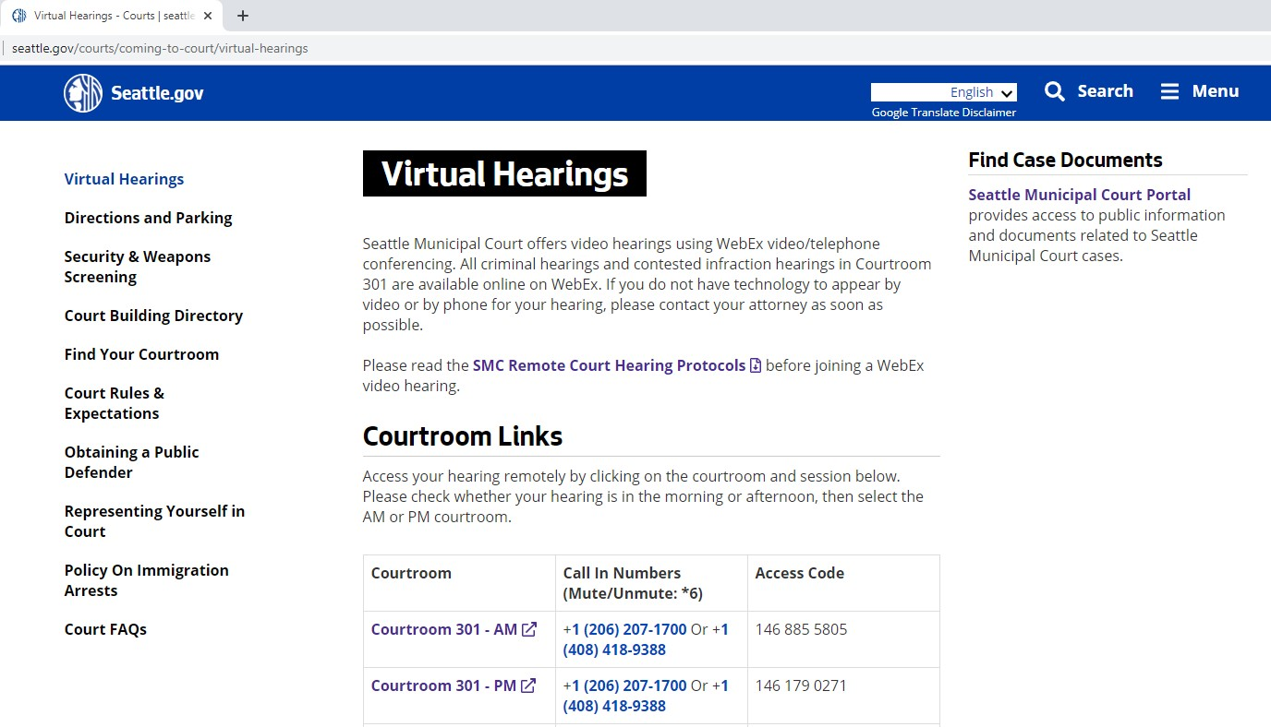

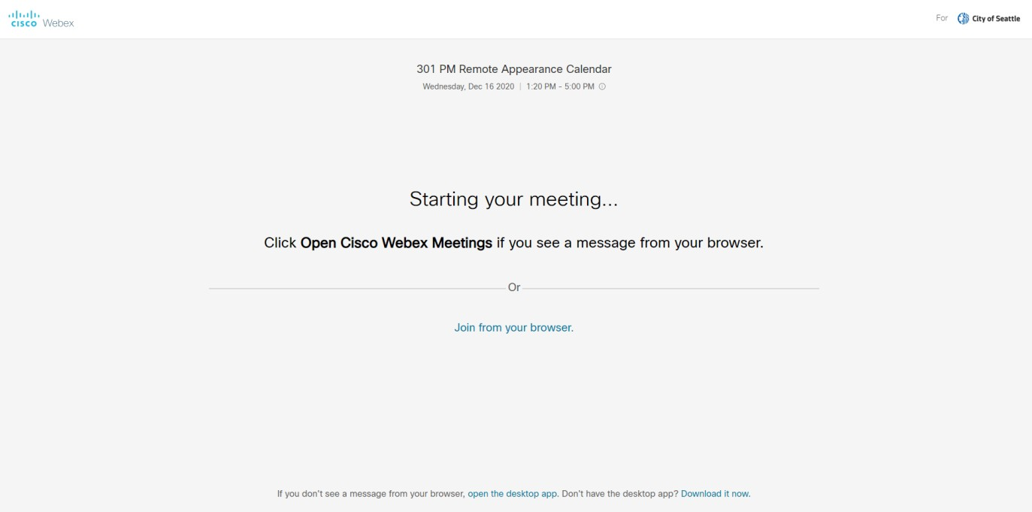

- Bogga khadkaaga wuxuu ku weydiiin karaa in aad soo degsato oo ku shubato xiraha WebEx (extenstion). Ayadoo ay ku xirantahay kumbuyuutarkaaga, waxaa laga yaabaa in ay laasim tahay doorashada “Run” si aad u soo degsato arjiga.
- Geli magacaaga koobaad iyo magacaaga dambe iyo iimeelkaaga, kadib guji “Next.”
- Waxaa ku daari ama ku damin kartaa makrafoonkaaga iyo kaamirada calaamadaha shaashadda hoosteeda. Markey calaamaduhu guduudanyihiin oo xariijin dhexmarsantahay, macnaheedu waa codkaagu waa xiranyahay kaamiradaaduna wey dansantahay. Fadlan makrafoonkaaga codka ka xir illaa aad hadleysid mooyaane kaamiradaadana daar inta dhegeysigaaga lagu jiro.
- Markaa diyaartahay, guji batoonka “Join meeting” ee cagaaran.
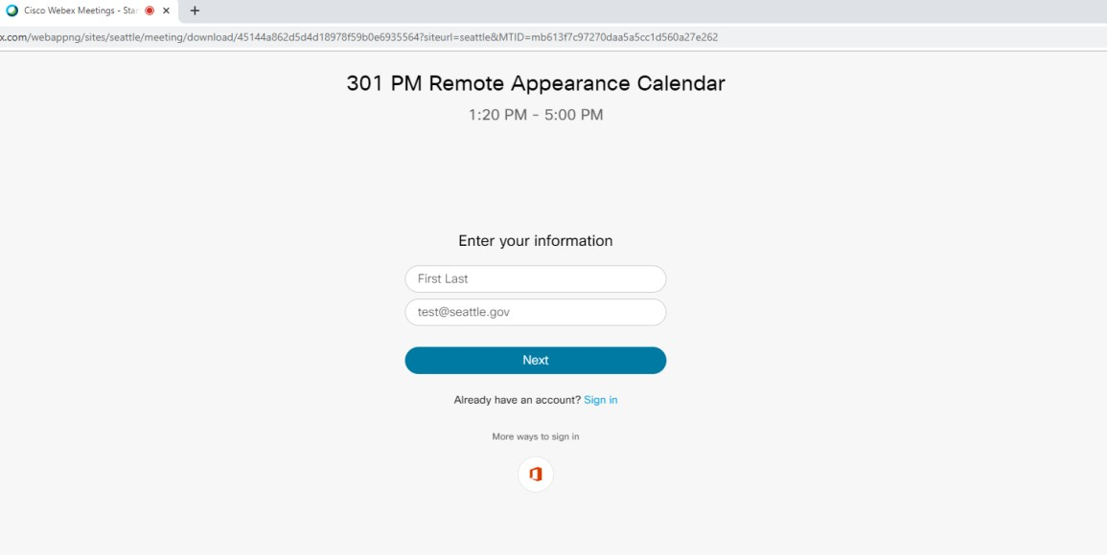

Page 2 December 2020

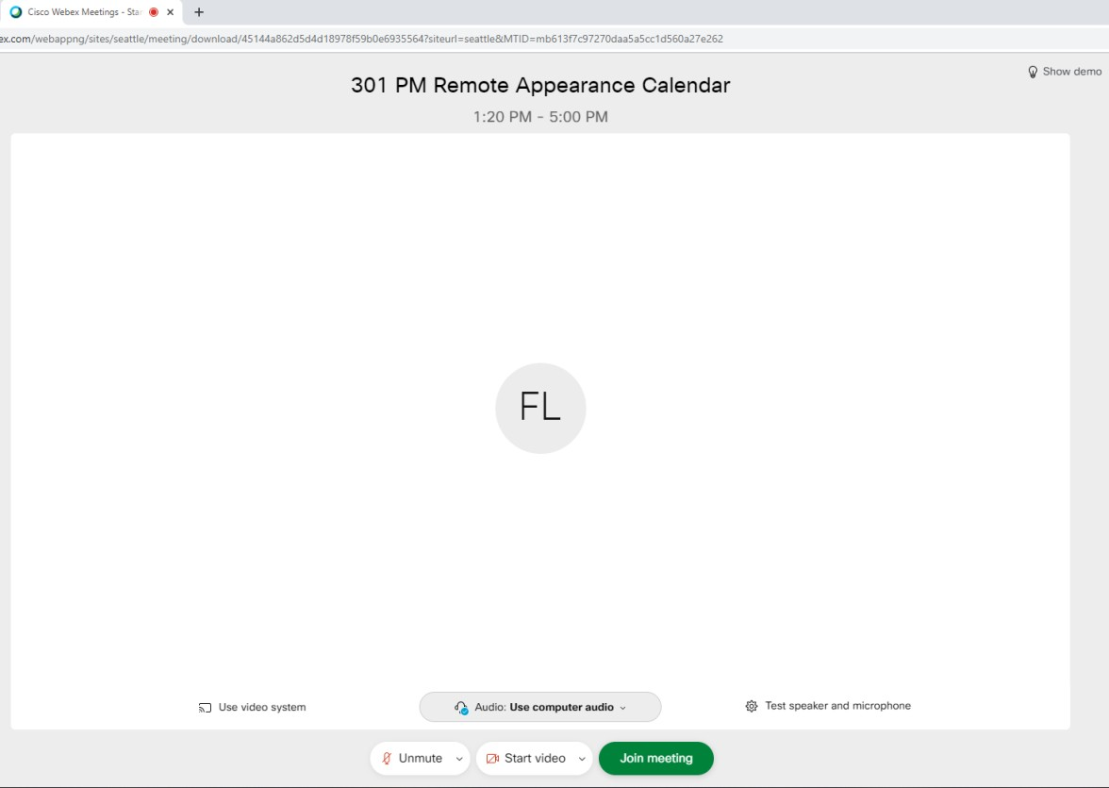

Khadadka bog ee WebEx oggolyahay:
  - Chrome (extension required – xire-khad u baahan) o Firefox (extension required – xire-khad u baahan)
  - Edge
  - Internet Explorer o Safari (Mac)

Page 3 December 2020

