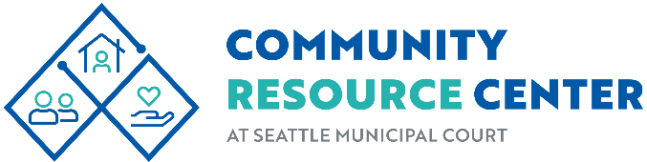
**WE NO LONGER OFFER FREE CELL PHONE SERVICES ON-SITE**
Daily Resources: Bus Tickets, Snack Bags, Hygiene Kits, Information & Referrals, as well as other everyday essentials. Clothing available for current Seattle Municipal Court clients.

HOURS & SERVICES
Open Monday - Friday 8:00 AM – 4:30PM PM


DAILY On-Site representative:
830AM - 4PM (last appointment may be taken at 3pm)
Benefits Specialist: Food, Income & Medical for low-income individuals.

MONDAY ONLY On-Site representatives:

9AM- 12PM (2nd, 4th and 5th Monday of the month)
Orca Lift Card, Food & Healthcare benefits & DSHS application assistance.


9AM – 12PM (last appointment at 11:30AM)
Coordinated Entry for All: Region-wide, streamlined housing support, Housing Diversion (remain housed), move-in cost assistance & information.

WEDNESDAY ONLY On-Site representative:

9 AM- 12 PM
Orca Lift Card, Food & Healthcare benefits & DSHS application assistance.

SEATTLE.GOV/COURTS/CRC 600 5th AVE #235 SEATTLE WA 98104 Ph: 206.684.9291 SMCCOMMUNITYRESOURCECENTER@SEATTLE.GOV

